Quality checking at PSS

   | This leaflet is about quality checkers and what they do
  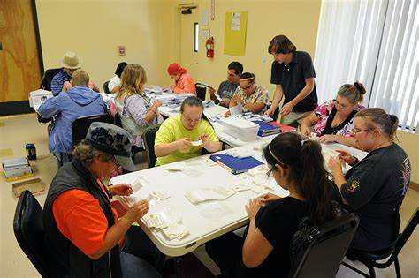 | Quality checkers are people who have got support from PSS before  PSS Shared Lives carers are also quality checkers
 | It is a quality checker’s job to do quality checks on our services
 | A quality check is a chat between a quality checker and a person who is supported by PSS or a carer with PSS
   | Quality checking is a way of seeing the good and bad in PSS
 | Quality checking helps PSS be better
 | The quality team record quality check information on PSS systems which keeps the information safe
 | Quality checks are used as part of reports to services and senior leadership
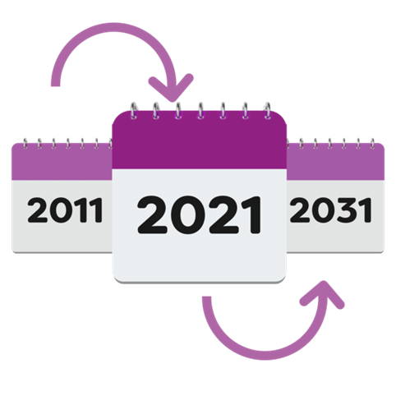 | Records of quality checks are kept for 10 years
 | Someone from our quality team will always be there to support the quality checker  They are called a co-checker
 | Quality checks can happen at any time of the year
   | Our quality team make sure quality checks happen at a time our quality checkers can do
 | When it is time to do a quality check, our quality team get in touch with our quality checkers
   | We share important information with our quality checkers by email, phone or letter
Quality checker meetings
   | Four times each year our quality checkers have a meeting
  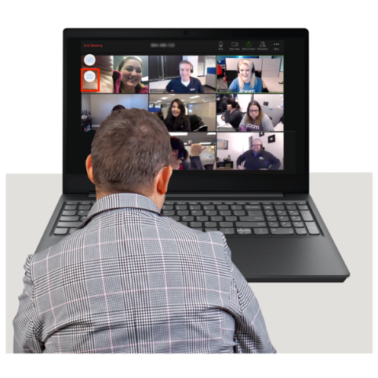 | The meetings are either in person or online
 | We have quality checker meetings to bring quality checkers together
 | To plan quality checks
 | To share when we have found out from doing our quality checks
 | To be better quality checkers
How we say thank you
 | We like to say thank you to our quality checkers
 | We give our quality checkers a £25 voucher for each check they do and each meeting they come to
 | It is up to the quality checkers if they want to take the voucher or not
  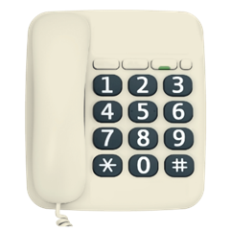 | If you want to be a quality checker get in touch with our quality team  You can email: qualityteam@pss.org.uk  or call 0151 702 555 and ask for a member of the quality team

